**Daily Scrum or Standup Meeting**

Team name: _______Hellz Kittens________

Scrum Master: _____Griffin Hackley________

Date:___________11-06______________

|  |  |  |  |
| --- | --- | --- | --- |
| **Team Member** | **What did you do since the last scrum?** | **What do you plan to do before the next scrum?** | **What obstacles do you have?** |
| Griffin Hackley | Bug fix | Implement unit tests | Time |
| Jack Miranda | Worked on implementing login system | Finish login system | No current obstacles |
| Laryssa Reveli |  |  |  |
| Gavin Reid | Worked on Post and fixed bugs | Finish post and build unit tests | Django n00b |
|  |  |  |  |

# Burndown

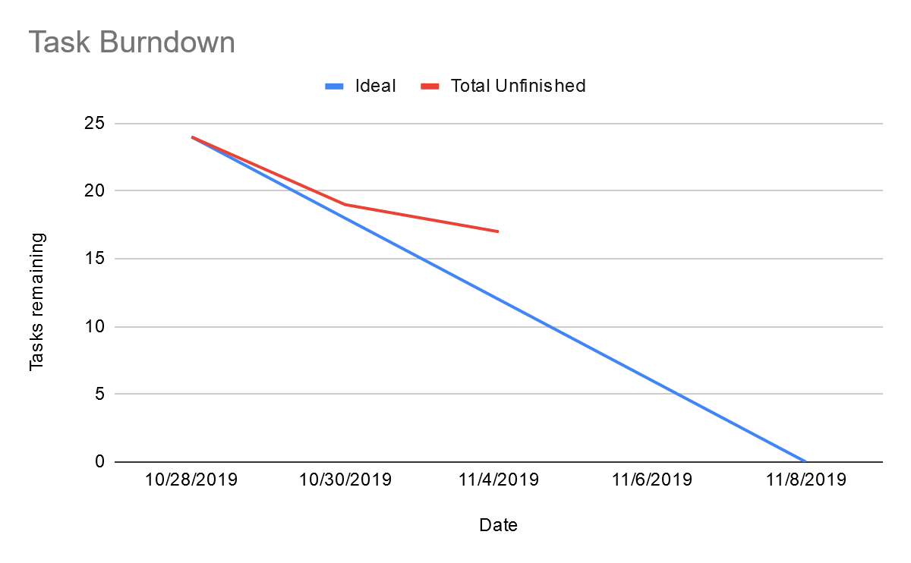

# Screenshot of you project board

